# **Simio API Note: Interfacing with Visio**

History

Creation: 06 Aug 2018

Update: 23 Feb 2023

Contents

**Simio API Note: Interfacing with Visio** 1

A Note About this Version 4

Overview 5

Quick Start 8

Design Considerations 8

What’s Included 9

A Simple Example 13

Use Cases 19

Facility Import: Interface Visio Diagrams with Simio Facility View 19

Convert Visio Diagrams to Processes 19

Convert Visio Diagrams to Tasks 19

Future Road Map 19

Implementation 20

Exchanged Information 20

Under the Covers – Legacy 24

Connectors 25

Appendix - Open Packaging Convention (OPC) 28

Appendix – Simio Diagram E**x**change (SDX) 30

Appendix – Visio Open Package Convention Document 31

Visio Components and Terminology 32

Stencils 32

Pages 33

The Document.XML 35

The Windows.XML 36

Pages Folder 37

Examining a Simple Page 39

Connector Shapes 41

Example: The “Source” Shape 44

Appendix – Developer Resources 48

The Drawing Control 50

Visio Documents 51

Appendix – Imported Data Conventions 54

Objects 54

Links 54

Vertices 54

Appendix – Excel OPC Format 55

XML File: sharedString 56

WorkBook File 57

WorkSheets 57

Appendix – Simio Project Container File (SPFX) 59

# A Note About this Version

This is a beta version to present the concepts that are being employed to permit drawings to be exchanged with Simio. As explained below, this technique introduces the **S**imio **D**rawing E**x**change (SDX) conventions that will be used to convert drawings to a format (a DataSet using SDX conventions) that Simio understands.

This release contains the following changes from the beta version:

1. Many minor bugs were fixed
2. The ability to reference object subclasses
3. The ability to include Simio properties from Visio
4. The ability to set the Simio name from Visio
5. Prevents importing a model on top of another model
6. The ability to automatically scale objects to normal Simio sizes.

To accommodate these, the SDX dataset went through some major revisions, including the addition of two more tables. The SDX dataset version is 18.09.07

# Overview

A Microsoft Visio document is a popular way to design and display visual information. This document describes how information created with Visio can be exchanged with Simio.

The simplest description of the process is this:

A Visio drawing is created (perhaps by using one the Simio Visio Stencils, such as SimioFacility.vssx). Once the diagram is created, the Visio Add-In is run. It prompts the user for (1) the Visio VSDX file and (2) a transform to locate the Visio drawing in the Simio location. This transform consists of an XYZ offset and scaling information, so that we know where to place the Visio objects and how big to make them. It then proceeds to creates the corresponding Simio Intelligent Objects (SIOs) and their links (and the link vertices).

Note: the Simio Visio Stencils are intentionally small and simple. This was done to allow drawings to fit more easily on a Visio page. Below the procedure is discussed to transform the drawing.

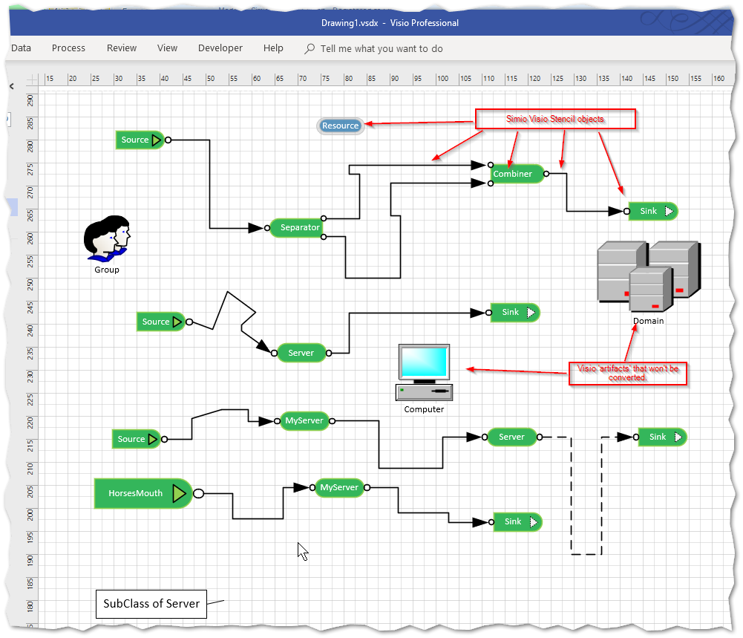

Figure 1 - Diagram Created in Visio using the Simio Facility Stencil

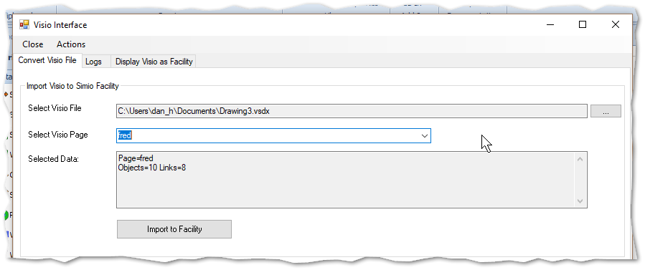

Figure 2 - Running the Add-In: Prompting for the Visio File

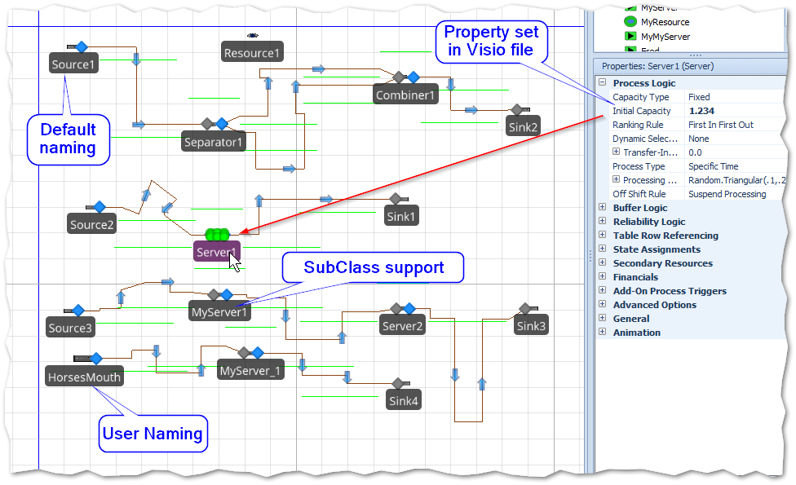

Figure 3 - Converted Diagram Running in Simio

## Quick Start

On the Simio Forum, a Package file (VisioAddIn.zip) is provided.

A small example illustrates this process. Using Visio and the Visio “Simio Facility” stencil, create a Source-Server-Sink model, as shown:

Make sure the VisioAddIn is in your user Document >> SimioUserExtensions folder.

Run Simio, and once loaded select the Facility tab and then Project Home >> Select Add-In and then choose VisioAddIn.

A form will prompt you for a location and scale. Just accept the default and press Import.

The Visio model displays on the view, and you can press the Simio run button to begin the simulation.

## Design Considerations

The Interface was built to have the following characteristics:

* It is consistent with other Simio-Interface standards, such as Excel-Import
* It can work with Visio drawings built with the Simio Stencils or with other Stencils if the user adds properties (Shape Data) to the shapes.
* It is consistent with Simio’s Data-Driven model philosophy
* It does not require COM or Interops, and it works with .NET Core
* Simple usage: minimal programming
* It does not need an installation of Visio to work; it only requires the .VSDX file.
* It uses not require 3rd party commercial products
* It leverages standards, such as Open Package Convention (OPC), Linq, and XML as much as possible.
* It provides accurate logging to help locate problems.
* Well-documented samples are provided with it.
* It defines a standard and workflow that could be used for other visual products; for example, importing AutoCAD drawings.

## What’s Included

Included with the Visio example is:

* All Source code (only the Add-In source is included now. All source will be eventually included)
* A Utility called SDX Harness that permits you to examine and preview your Visio document.
* Visio stencils for the Simio drawings (only the Facility stencil is included at this time).
* An example Visio VSDX file containing basic Simio Shapes from the SimioFacility Stencil.
* A library for generating a Simio DataSet from a Visio file.
* A library for using a Simio DataSet to create a Simio Facility
* A Design-Time Add-In that employs both libraries to convert a Visio file to a Simio Facility
* An accompanying 5 minute video that illustrates the process.

Based on these characteristics and input from Simio users and partners, the following architecture was derived:

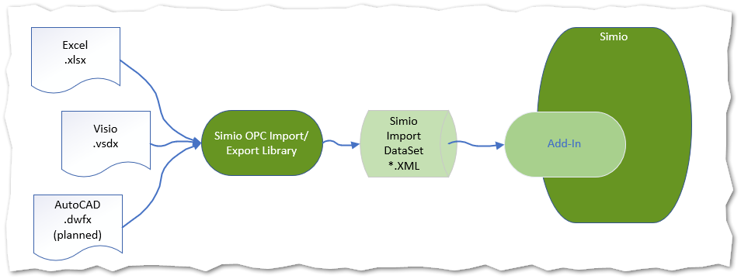

Note that the Library can be used by external programs, but can also be called from within the Add-In, and could then be visualized like this:

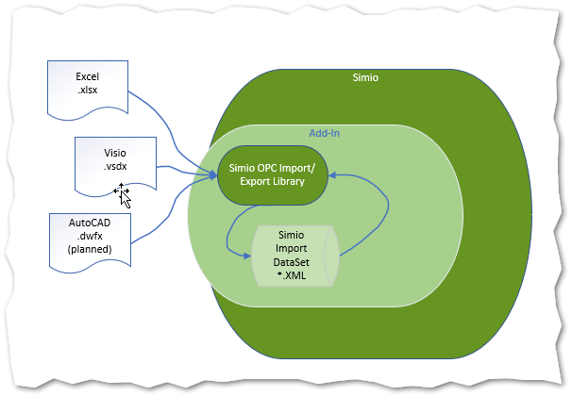

Regardless, the process is still the same: A Simio-Visio-OPC Library is used to read the Visio file and creates a standard Simio Import DataSet. This DataSet contains seven Tables:

1. Properties to identify the DataSet type and contents
2. Objects to hold the Simio objects such as Source, Server, Sink, etc.
3. ObjectProperties, which hold Simio properties for Objects
4. Links to hold the connectors
5. LinkProperties, which hold Simio properties for Links
6. Vertices which hold information about how to draw the connectors
7. Artifacts that were found, but cannot be converted to Simio

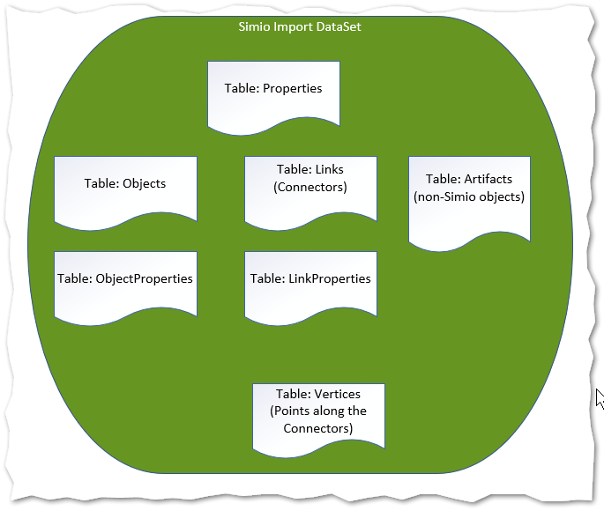

Figure 4 - DataTables in the SDX DataSet

There are three different types of DataSets corresponding to Simio views:

1. Facility View
2. Process View
3. Task View

In this release there are examples only for Visio, with Excel to be included before the final release. Other applications that employ the OPC Package file standard - such as AutoCAD (Autodesk) and Simulink (MathWorks) - are also candidates.

Also, this release only contains an example for the Simio Facility View. The Process and Task views are planned for a future release.

## A Simple Example

Consider a Visio example that is to server as a basis for a Simio project. This is a worse-case example, since this drawing only contains pictures. That is, there is no inherent logic, only the rough shape and placement could potentially be used.

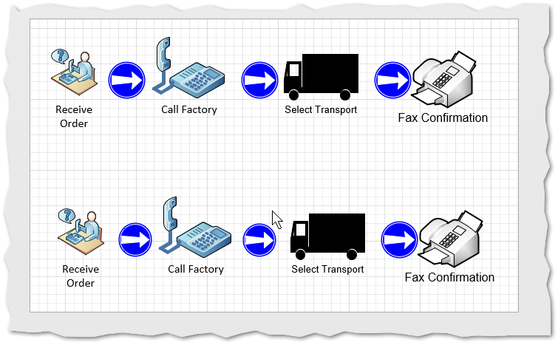

Figure 5 - Simple Example. No inherent logic.

When the SDX Harness is run, the Preview window displays the objects in gray, as they are not candidate Simio objects, as there are no Simio Shape-Data properties.

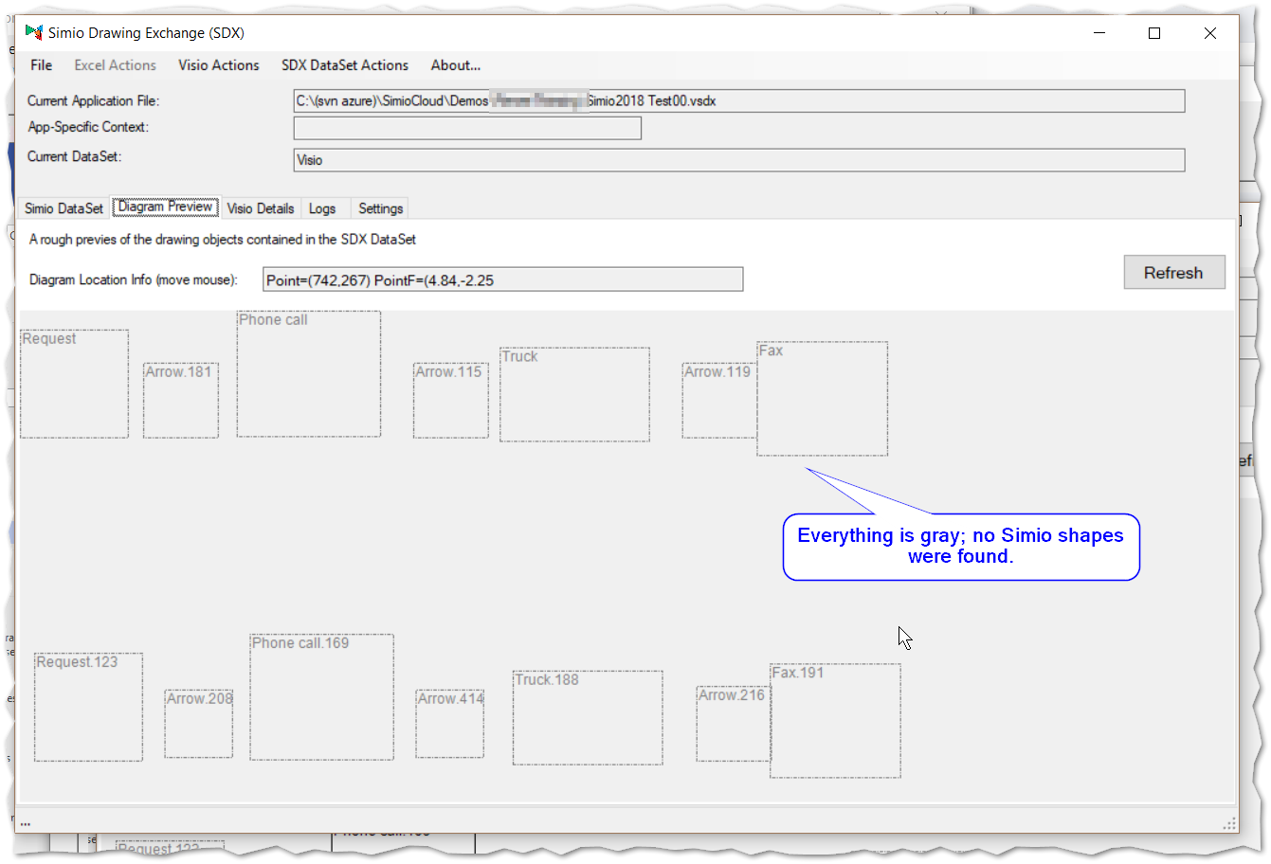

Figure 6 - Simio Import Preview

So, there are two possibilities for adding more information so that the Add-In can make Simio objects:

1. Use the Simio stencil, or
2. Add Shape-Data to make them Simio-able.

In the first case, we’ll use the Simio stencil and add a simple source-server and import again to demonstrate the difference.

From the stencil, a Source and Server are added. An MRC (Mouse-Right-Click) on the server and selection of the “Define Shape Data” shows the values of the required Name (Simio_ObjectClass) and Value (Server).

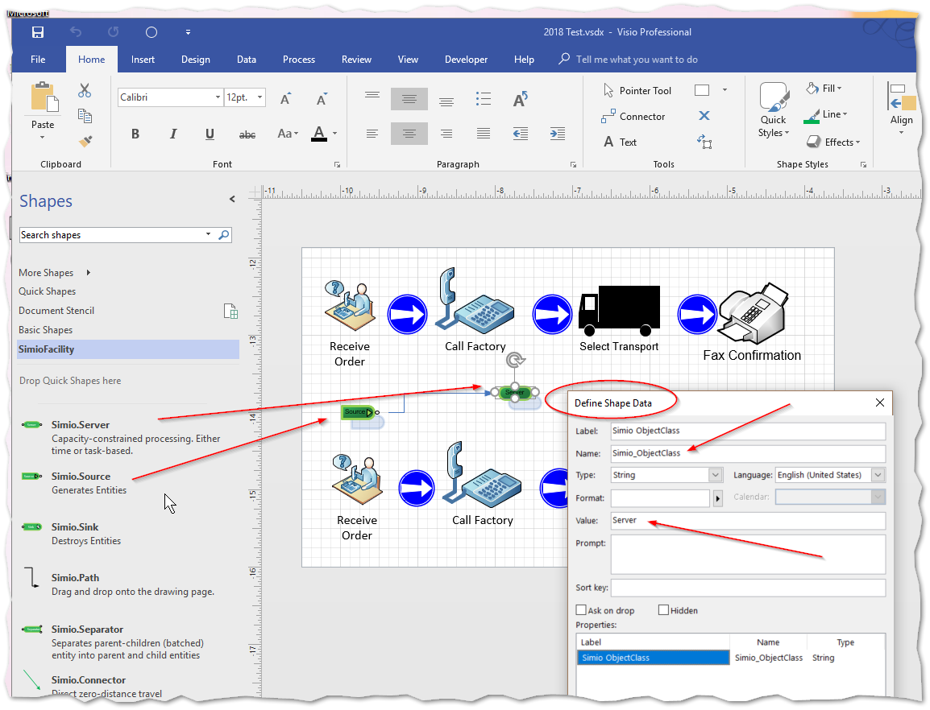

When the Import is done, the Source and Server are now visible and highlighted.

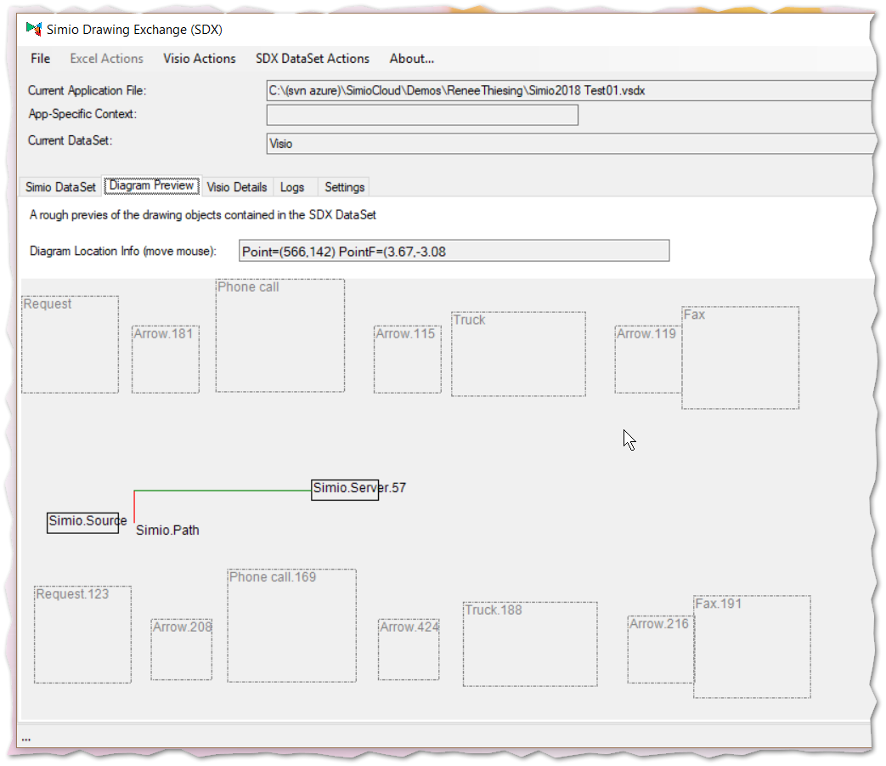

Next, we’ll alter the Shape-Data of “Call Factory” and “Select Transport” to indicate that they are Simio Source and Server, respectively. And then well add a Simio.Path between them:

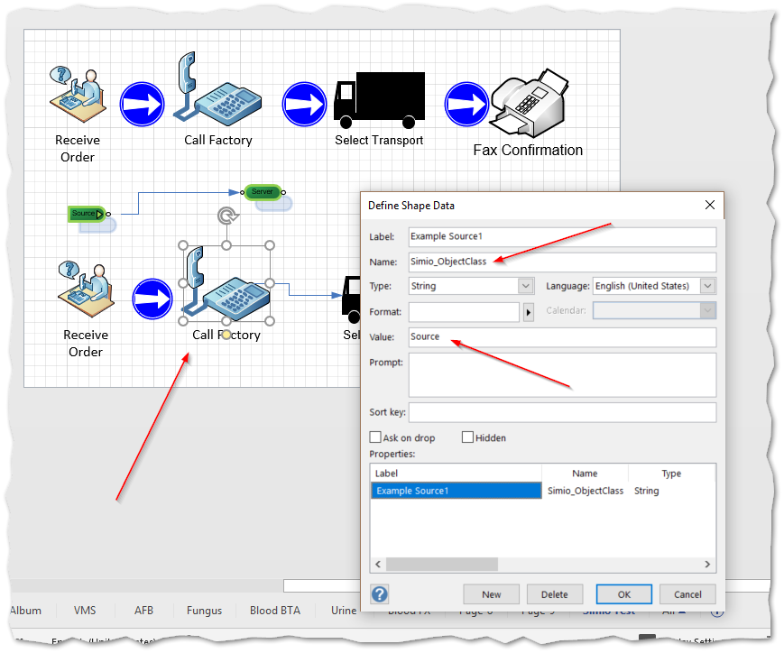

When this is imported, the Previewer shows that they are now treated as Simio objects:

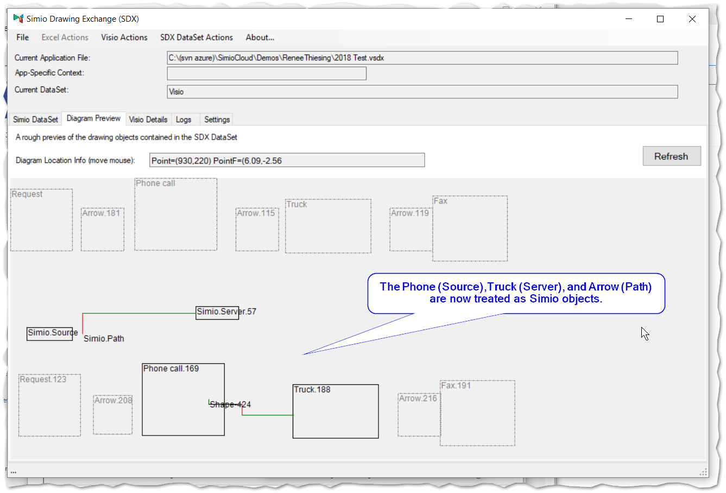

Figure 7- Shape-Data added to Phone and Truck. Note that they now have black outlines.

# Use Cases

This section discusses some of the Use Cases considered for this Interface

## Facility Import: Interface Visio Diagrams with Simio Facility View

This is perhaps the most asked-for interface and perhaps the most obvious one. Because of this, it is the first interface developed. Consider that you wish to draw a diagram using a standard Visio product to be later employed in a Simio model. This might be done during the design of a project where it is easier to demonstrate how the simulation would look to a project’s stake-holders, but then periodically (or perhaps at the end of the project) quickly import it to Simio to implement the simulation.

## Convert Visio Diagrams to Processes

In a similar way Processes could be constructed, so that instead of IntelligentObjects for the objects there would be Steps.

## Convert Visio Diagrams to Tasks

In a similar way Tasks could be constructed, so that instead of IntelligentObjects for the objects there would be Tasks.

## Future Road Map

There is nothing that prevents the reverse of these Use Cases. That is, exporting from Simio to a Visio diagram, but this is not planned in the first release.

# Implementation

In this section we’ll discuss the architecture in general, but specifically discuss the Visio to Simio Facility View Use Case as the example.

## Exchanged Information

It is necessary when building any interface to determining the data that is needed, and how to extract that data.

The information that this Simio Add-In employs was derived from two existing sources:

1. The object, links, and vertex format already employed in the existing Simio Excel spreadsheets import, such as seen the Add-In ImportObjectsAndLinksFromSpreadsheet, and
2. Importing Objects and Links (Simio’s Table-Base Objects, i.e. Auto-Create)

For example, for importing data into the Simio Facility model, we need to know (at a minimum) the following about the objects.

1. The Name
2. The Simio Class (the type of object, such as Source, Server, Sink, …)
3. The location in X,Y,Z space
4. The size (Width, Height, Depth/Length)
5. And any other property that we don’t want to default.

And for the connections, the information needed is:

1. The Name
2. What type of connection, if any (e.g. Path, TimePath, …)
3. The beginning and end points on the Object
4. A list of segments (which may be only one segment).

For Visio, most data can be derived from standard Visio data. This includes name, location, size, connectors, etc. Thus, the essential data missing is the Simio names for the object classes, such as ObjectClass and LinkClass.

To get ObjectClass it is necessary to employ other techniques. Visio provides a convenient way to do this, which is essentially user-defined “Properties” of a Shape. In the Visio interface this seen as a feature that is (somewhat oddly) named “Shape-Data”.

*Note: Do not confuse Visio Shape-Data with the Visio Shape-Sheet. Internally, Shape-Data is the “user defined” part of a Shape-Sheet, and is what Simio uses to allow the user to associate custom data (e.g. Simio Object Classes) with a Shape. Think of Shape-Data as User-Defined Properties. There is more information about this in the Appendix.*

The conversion library needs to know the following information about an ObjectClass object:

* The Simio Object Name (e.g. “Server”)
* How many transfer nodes, and of what type (Input or Output)

For example, a Simio Server has two transfer nodes (1 input, 1 Output). A Source has one (Input) and a Separator has three (1 Input, 2 Output). This node information is used when validating the connecting LinkClass objects.

Our interface employs Shape-Data to store the Simio data (properties) that are needed, and by convention the ‘properties’ (Rows) of the Shape-Data used by Simio are prefixed with “Simio”. For example, the ObjectClass property that Simio needs can be found in Visio Shape-Data as the Name Simio_ObjectClass, and its corresponding “property” value (for example “Sink”.

The Simio Visio Stencils can be used to make this more convenient. The following diagram shows part of the Stencil that is used for creating Facility diagrams.

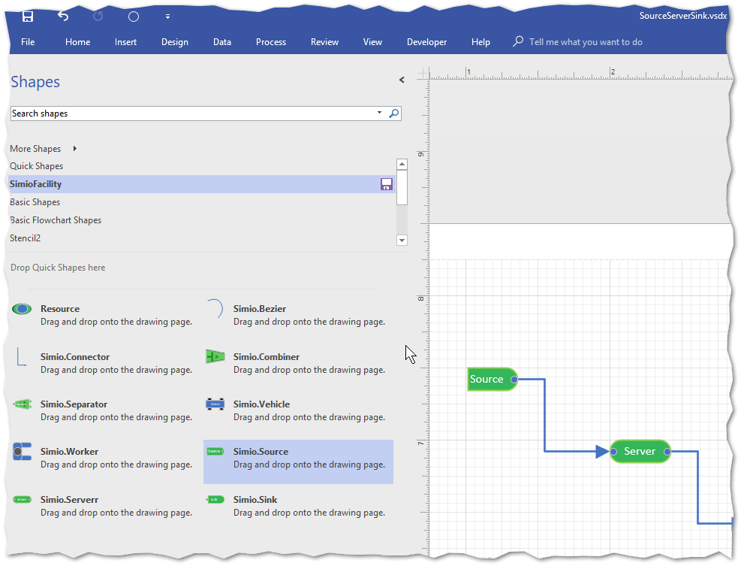

Simio provides custom Simio Stencils for Visio. These stencils already have these properties defined to make usage more convenient, but a user in a legacy situation with an already existing drawing need only add this Shape-Data to make the interface work.

This is done by doing a MRC (Mouse-Right-Click) on an object, and then following the steps as shown in this diagram:

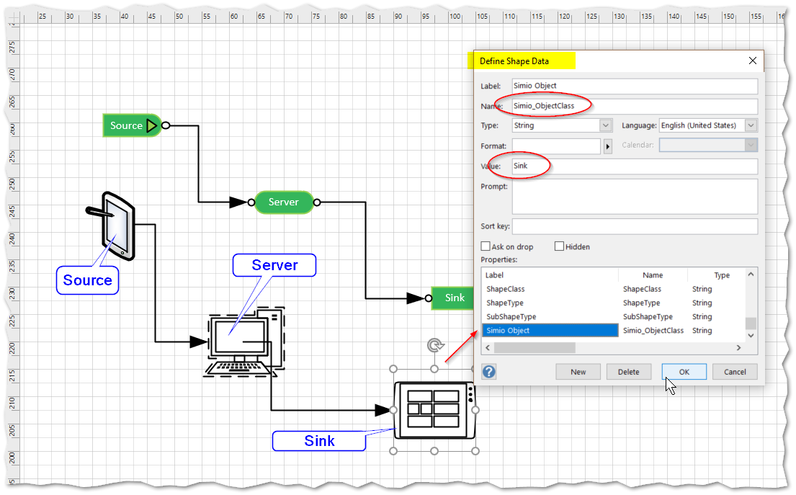

Figure 8 - Defining Properties (Shape-Data) for a Legacy Drawing

And then define the Simio Shape Data: (Note: The Name must begin with “Simio_”), and the Value must be one of the predefined values (Source, Server, Sink, …)

The result is the same as the Source-Server-Sink that was built with the Simio Stencil:

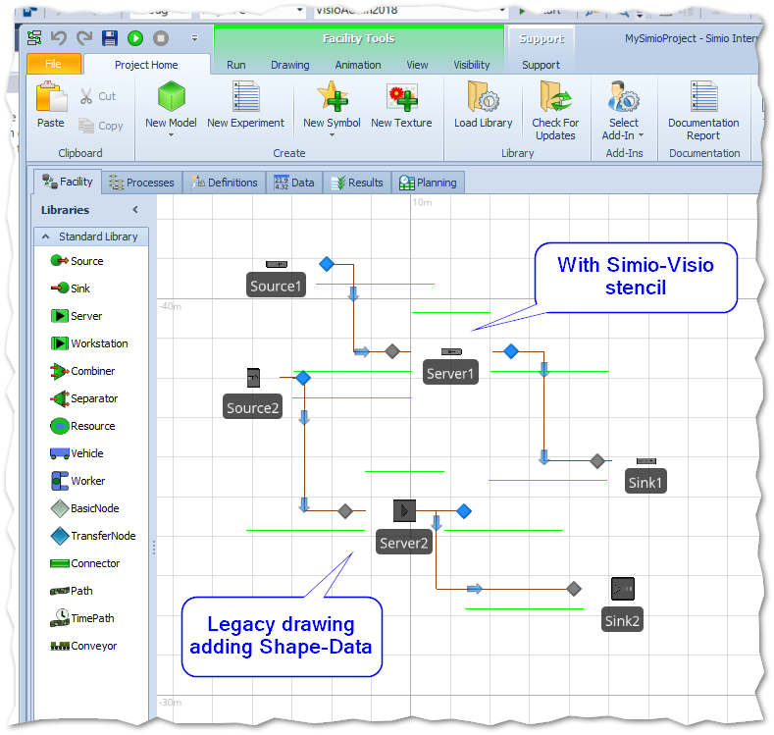

Figure 9 - Imported Facility using Legacy Visio Drawing

When this is done properly, the Shape will show Simo_ObjectClass with the value of “Source”:

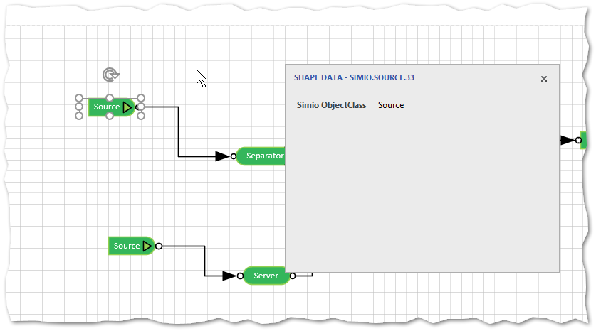

### Under the Covers – Legacy

Let’s look at our ‘legacy’ example of the Laptop as the Server. Within the package file under the Visio > Pages folder we’ll find a Page3.xml. Scanning through it we find our Laptop Shape:

Since we did not use a Simio Master stencil, all the information we need is here is in our Shape-Data, which is found under the XML Element ‘Section’ with the ‘N’ (Name) property ‘Property’. In the Row named ‘Simio_ObjectClass’ we just have to look in the Cell with ‘N’ of ‘Value’, and then pick up its ‘V’ value to get the fact that this is our Server.

Note that all the Name (‘N’) and (‘V’) convention used by Visio can get confusing, (I believe the reason Visio did this was because Name and Value are used so often that by abbreviating them to a single letter they were able to keep the file size smaller).

At any rate, this is all ‘under the cover’, so the provided interface software will do all this. *As a user, you need only to add the Shape-Data with the Simio conventions to your Visio-Shape.*

## Connectors

Connectors are a different challenge. In Visio, connectors are just another type of Shape, and they can have more flexible geometry than Simio permits. But we can define the Visio connector as a Simio Link object (such as Connector, Path, etc.) provided by the Simio Facility Stencil to generate straight-line segments that can be employed by Simio.

Let’s take the Legacy example first:



Figure 10 - Note: This Should be Simio_ObjectClass instead of Simio.Classname

The XML IDs are:

* Source (XML Web Service) ID=17
* Server (Laptop) ID=13
* Sink (Data) ID=31
* Source to Server Connector (ID=38)
* Server to Sink Connector (ID=37)

At the very end of the Page3.XML file is the ‘Connect’ Element:

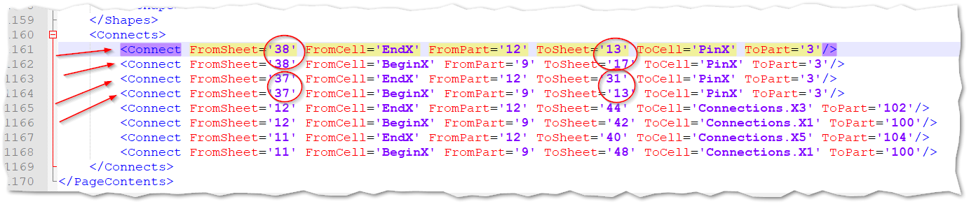

Here, we are interested only in the first four ‘Connect’ Elements.

Remembering that the Connectors are Shapes also, let’s look at ID=38, which connects the Source to the Server. The important items to note are the BeginX and EndX that are specified in the Connect Elements.

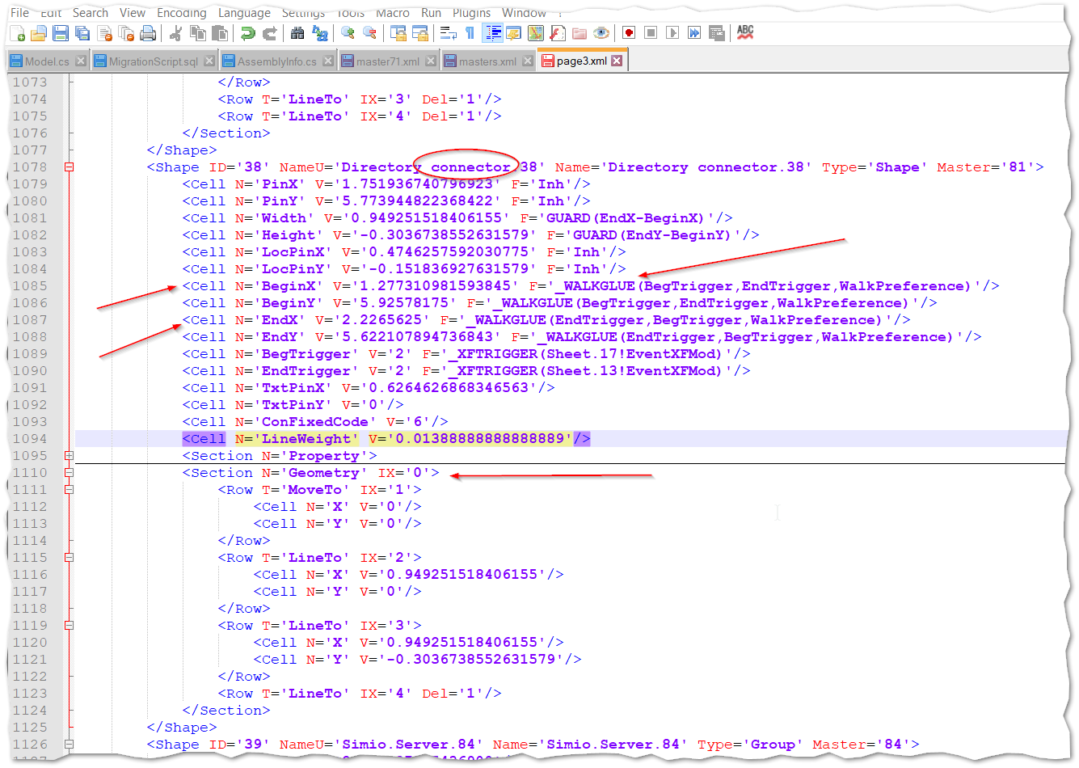

You can see in the diagram below that these match to the points where the connector Is glued to the Source and Sever.

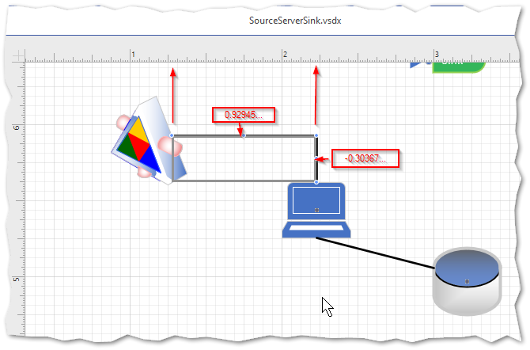

And in the geometry, you can see that the movements are in relative coordinates, starting at 0,0 and them moving horizontally (X) about 0.949 units to the right and them moving down about -.303 units.

# Appendix - Open Packaging Convention (OPC)

The Open Package Convention defines a standard way to store many types of data in a single container.

According to Wikipedia:

The Open Packaging Conventions is a container-file technology initially created by Microsoft to store a combination of XML and non-XML files that together form a single entity such as an Open XML Paper Specification document. OPC-based file formats combine the advantages of leaving the independent file entities embedded in the document intact and resulting in much smaller files compared to normal use of XML.

Microsoft Office uses this convention for several product, including Visio (from Visio2013 forward).

Microsoft provides OPC package operations via API found in System.IO.Packaging.

You access (Open) a package like this:

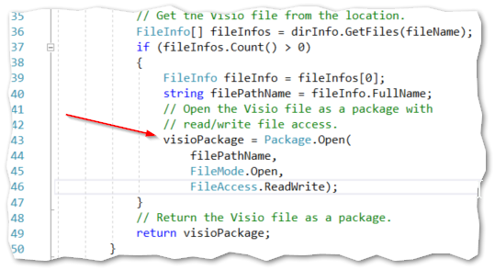

And then get its Parts like this:

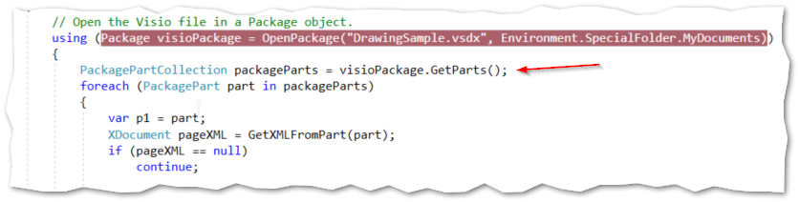

You can get data from a ‘Part’ as shown here to get an XDocument

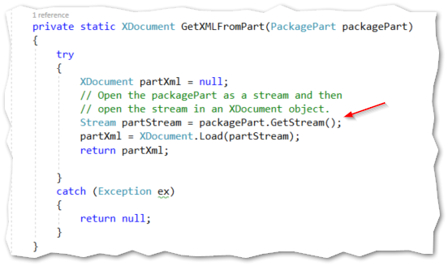

More examples can be found in the Appendices specific to Office products such as Excel and Visio.

# Appendix – Simio Diagram E**x**change (SDX)

The Simio Diagram E**x**change (SDX) is a standard format that drawings from external packages can be converted to so that Simio can use them.

It consists of four tables:

1. Properties (meta-data that helps Simio interpret the other three tables)
2. Objects – The objects that Simio must convert. For example, Intelligent object for the Facility View.
3. Links – The connectors that connect the Objects. Each link references two objects. For example, Path, TimePath, etc. in the Facility View.
4. Vertices – The geometry of the Links. Each vertex references. Each vertex references a Link and are an ordered set.

The default view for Simio is looking ‘down’ from up on the Y axis. The view is isometric so that it looks like a regular X,Y diagram (except that it is X,Z). It is thus a “right-handed” coordinate system.

All coordinates use Simio conventions:

When looking ‘down from above’:

1. The origin is at the upper left
2. The horizontal axis is the X axis
3. The vertical axis is the Z axis
4. The Y axis is coming toward you (increments ‘up’ from the origin).

The nomenclature for ‘Size’ is:

* Width is along the X axis
* Length is along the Y axis (‘Depth’)
* Height is along the Z axis

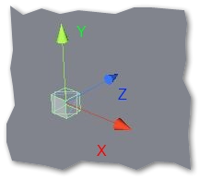

# Appendix – Visio Open Package Convention Document

This Appendix explains how Visio employs the Open Document Convention (OPC) file to implement its .VSDX files. The OPC structure is

1. Folder _rels
   1. File .rels
2. Folder docProps
   1. File app.xml
   2. File core.xml
   3. File custom.xml
3. Folder visio
   1. Folder _rels
   2. Folder masters – Contains masters.xml and master#.xml
   3. Folder media
   4. Folder pages – Contains pages.xml and page#.xml
   5. Folder themes – Contains files theme#.xml
   6. File document.xml
   7. File windows.xml – Contains Stencil references

Microsoft has extensive documentation about this format here:

<https://docs.microsoft.com/en-us/office/client-developer/visio/introduction-to-the-visio-file-formatvsdx>

## Visio Components and Terminology

We are interested in extracting information from the Visio parts so that we can give enough information to the Simio API to build the Simio SDX DataSet (in XML format). Included in the SDX release is a sample builder (SDX Harness) that reads Visio diagrams and converts any selected Visio Page into a SDX DataSet.

This SDX DataSet can them be included in to your Simio project using the VisioAddIn.

Stencils and Pages

### Stencils

Stencils contain Masters (or Master Shapes, if you prefer), and Masters are templates used to build Shapes on a Page.

Embedded in the file is data that is used to determine how Simio can use each Shape. Each Shape can have user-defined data (properties) associated with it. This information is stored in a Section called Shape-Data.

### Pages

And here are some examples for getting items from the XDocument:

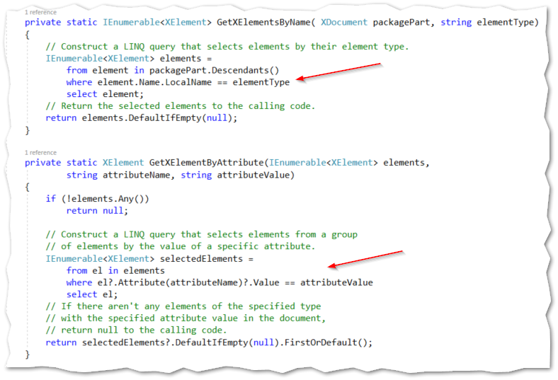

The structure of a Visio Project file (such as example.VSDX) can be viewed from File Explorer by changing the extension to “.zip”, and then examining the file structure:

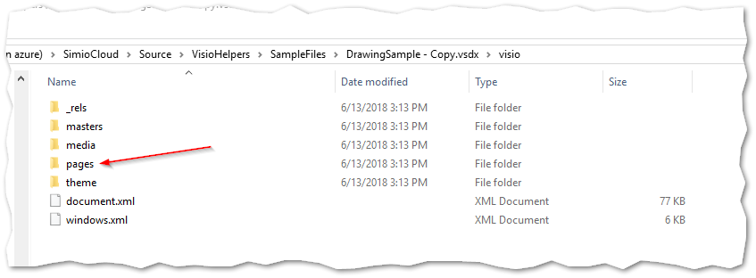

### The Document.XML

The contained document.xml file describes the overall document settings, FaceNames (e.g. Calibri), StyleSheets, and the DocumentSheet.

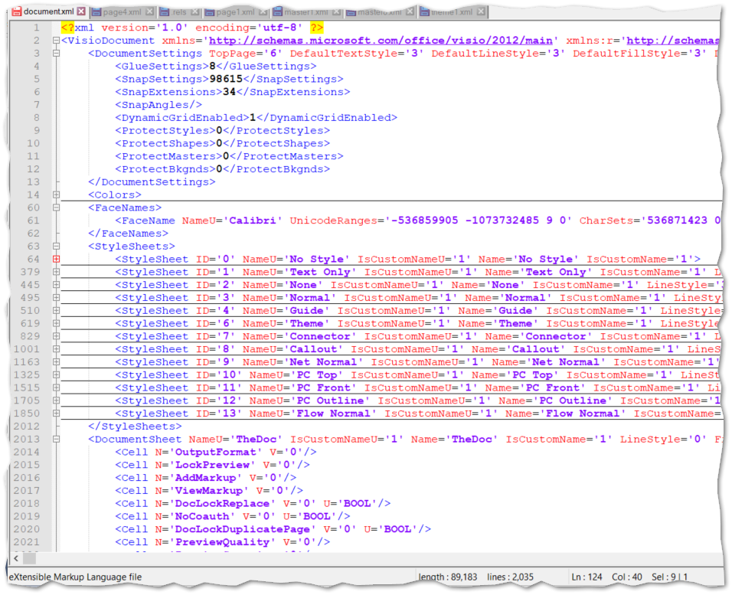

### The Windows.XML

This file describes the Visio Windows, which include child-windows such as Stencils. As seen, each ‘Stencil’ window references a “.vssx” file. These are also OPC files but differ from the “.vsdx” files in that they have no pages (no page{n}.xml files under the pages folder).

When you create your own stencils, they appear as “.vssx” extension files under “My Shapes”, which is under your user’s Document folder.

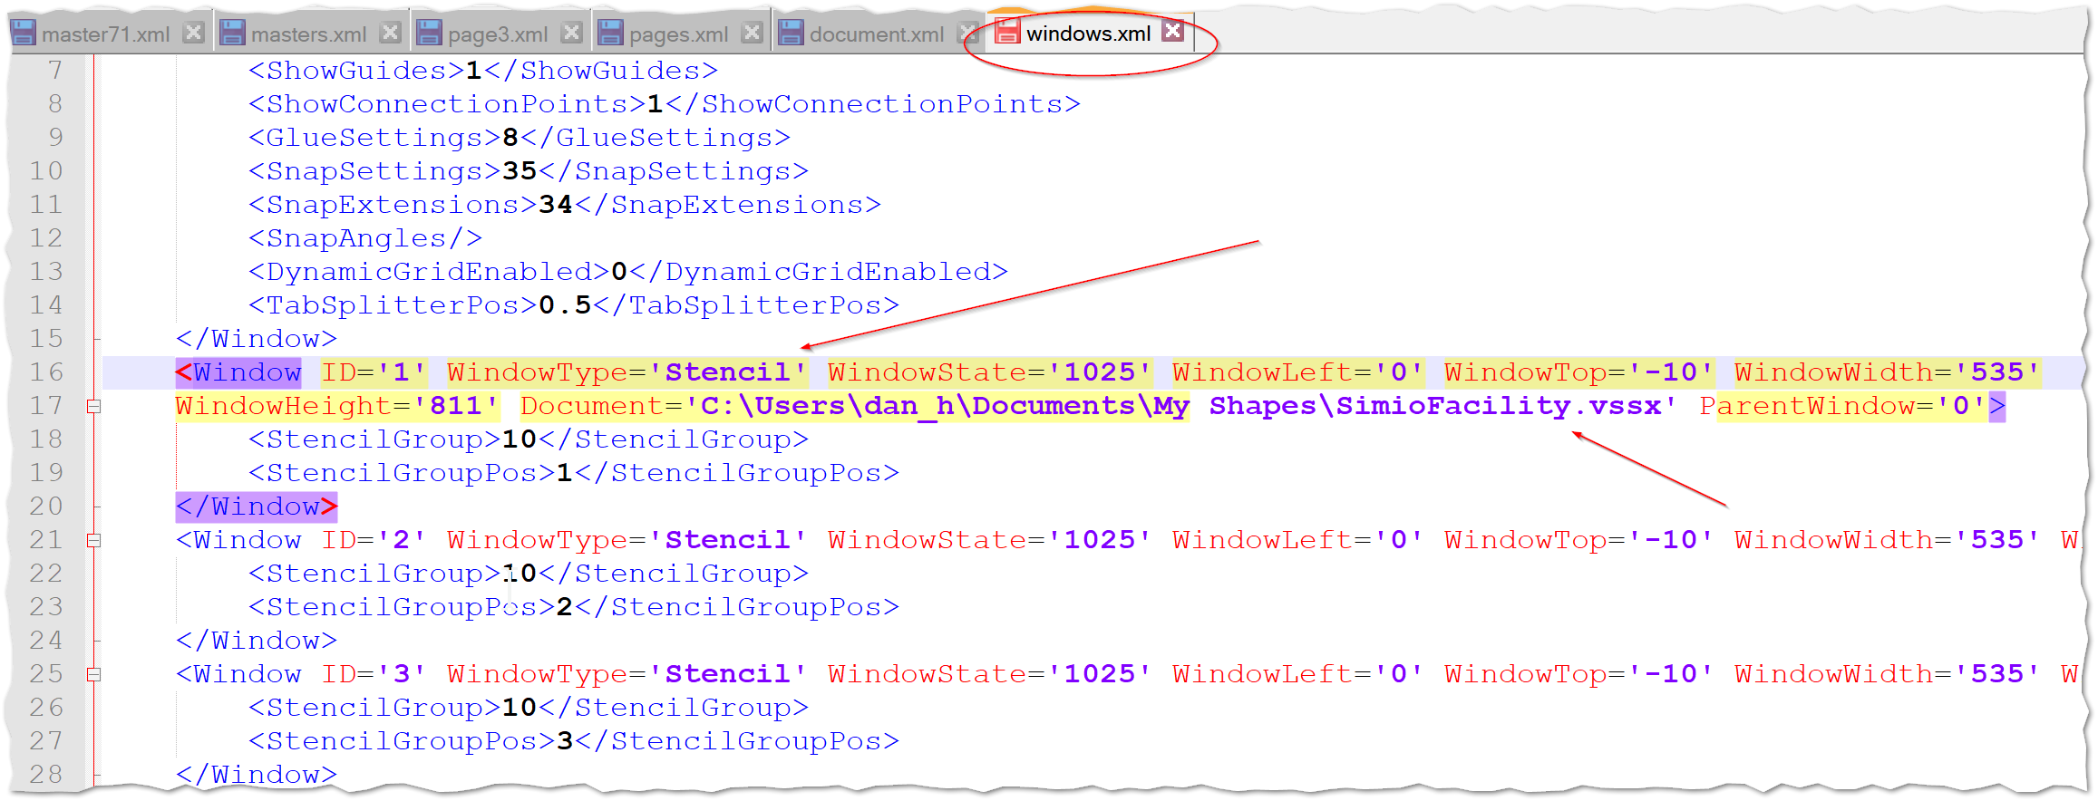

Figure 11 - Windows.xml File, Showing Stencils

### Pages Folder

Under the Pages folder are pages.xml and page{n}.xml files. Pages is a directory of all the page files. The individual page{n}.xml files in the pages folder is the motherload: it contains the drawings and correspond to the Page tables in the Visio application.

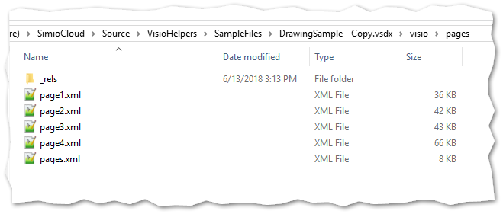

As mentioned, the pages.xml file contains a reference to all the individual ‘page{n} files:

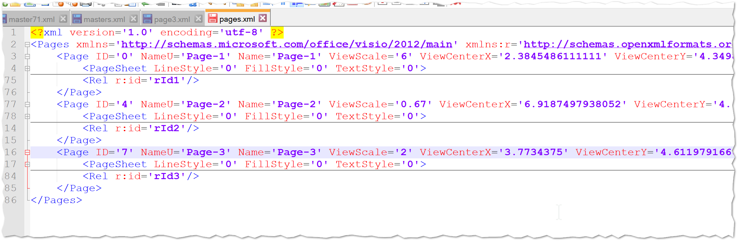

#### Masters Folder

The Masters folder has a structure like pages, with a file (master{n} for each Master shape (from the Stencil) and a global Masters.xml file:

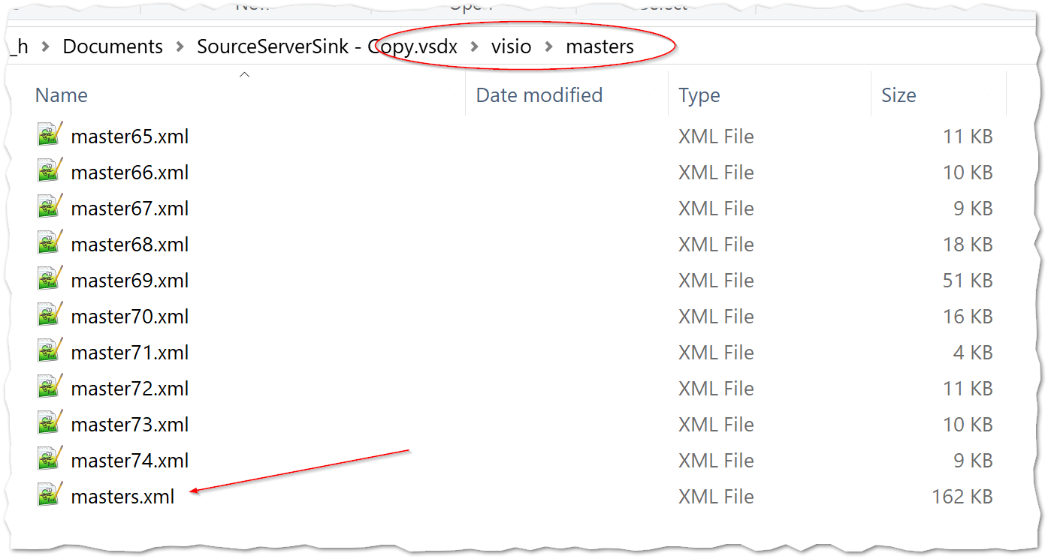

### Examining a Simple Page

It is instructive to examine a single simple page.

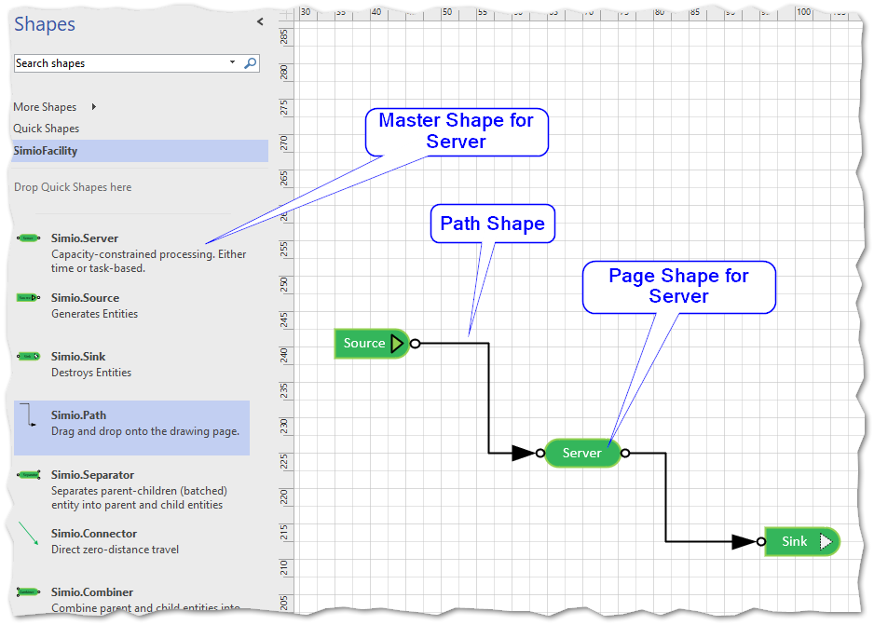

Figure 12 - A Simple Page

On the left is the Stencil (SimioFacility in this case). Each Shape in the Stencil is a Master. (as mentioned above, the Stencil itself – if custom – is found under User > Documents > MyShapes as a .VSSX file).

Each Shape in the diagram area is constructed from each “Master” shape from the Stencil. Each Master shape can be found by going to the “visio > masters” folder within the VSDX file and looking locating its master{n}.XML file (e.g. master23.xml)

The Shapes on the diagram Page are found within the folder “visio > pages” inside a page file (e.g. page1.XML).

Let’s look at the Server’s Shape first. Within page1.xml we find the following Shape section.

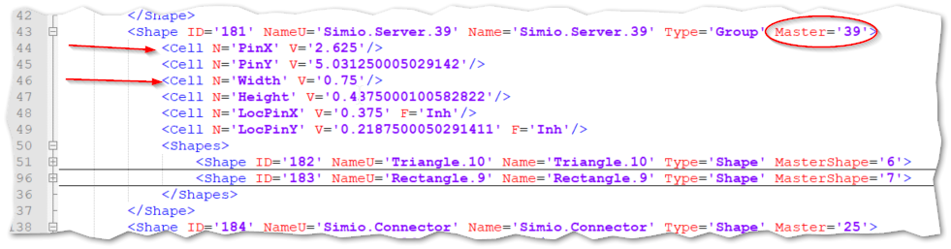

In this case the user had resized the Simio.Server Shape, so the Width and Height properties (Cells) exist for the Shape. But they would be missing if they had not, since Visio efficiently doesn’t bother since the default size is stored in the Master. In which case, we would have noted our Master ID (39) and opened the visio > master > masters.xml file and first located the Master with ID ‘39’.

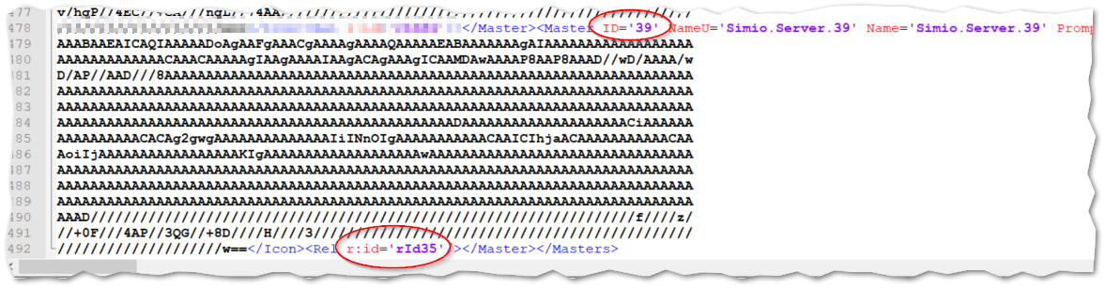

Figure 13 - Finding the Master file from the Shape

Note: the large encoded string is the icon used in the stencil.

Once we have located the Master, we can get the “Reference” ID of the Master the Reference ID (r:Id) which has the value rId35. And finally, we can parse this to get ‘35’ and then grab the Master35.xml file, to get the size dimensions (or any other Master default).

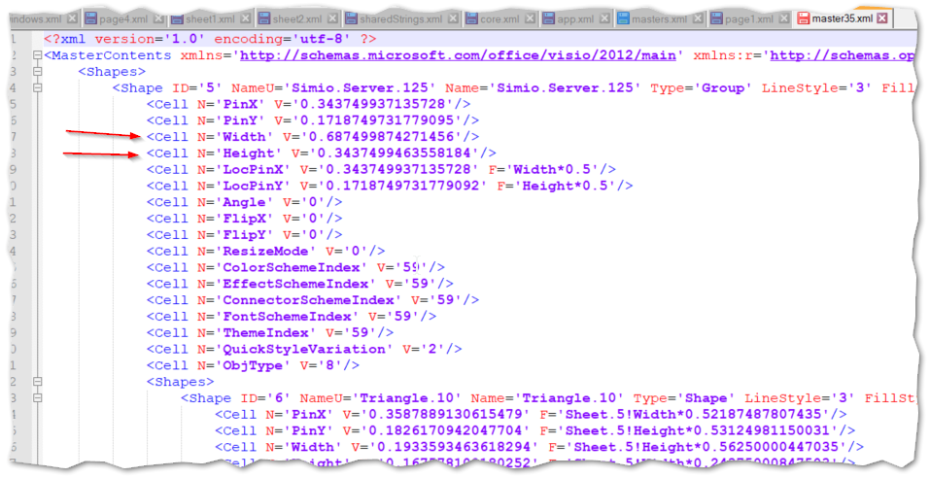

Again, only the contents of the Shape that differ from the Master are duplicated. And this is important because if – for example - we want to get the location and the size to pass them on to Simio, information like the location will always be in the Page Shape, but the size will only be in the Page file if the size was changed. If it hasn’t changed, then we must go to the Master to fetch it.

To repeat, the procedure to find the Master is:

1. Find the Shape from the correct Pages folder.
2. Get the Master ID
3. Look in the Master.xml file in the Masters folder and find the r:id Attribute from the Rel Element (for example <Rel r:id=”rId65” />
4. Get the id number after the ‘rid’ (for example 65)
5. Use this Rel id and find the Master{nn}.xml file (for example Master65.xml)
6. This is the Master that the Shape used.
7. If the Shape did not have a Property with a Label Simio.ObjectType, then the Master should have.

### Connector Shapes

Let’s now look at the Visio connectors, which become Simio Links. Connectors are also Visio Shapes, but have a special section at the end of each Page{n}.xml file with the element ‘Connects’. Nested within Connects are a series of ‘Connect’ elements, each with a ‘FromSheet’ and ‘ToSheet’.

Each connecting Shape has special Cell elements called BeginX, BeginY and EndX, EndY. Visio arbitrarily uses the BeginX and EndX in the Connect section, since to know the ‘X’ allows the selection of the ‘Y’ from the Shape section.

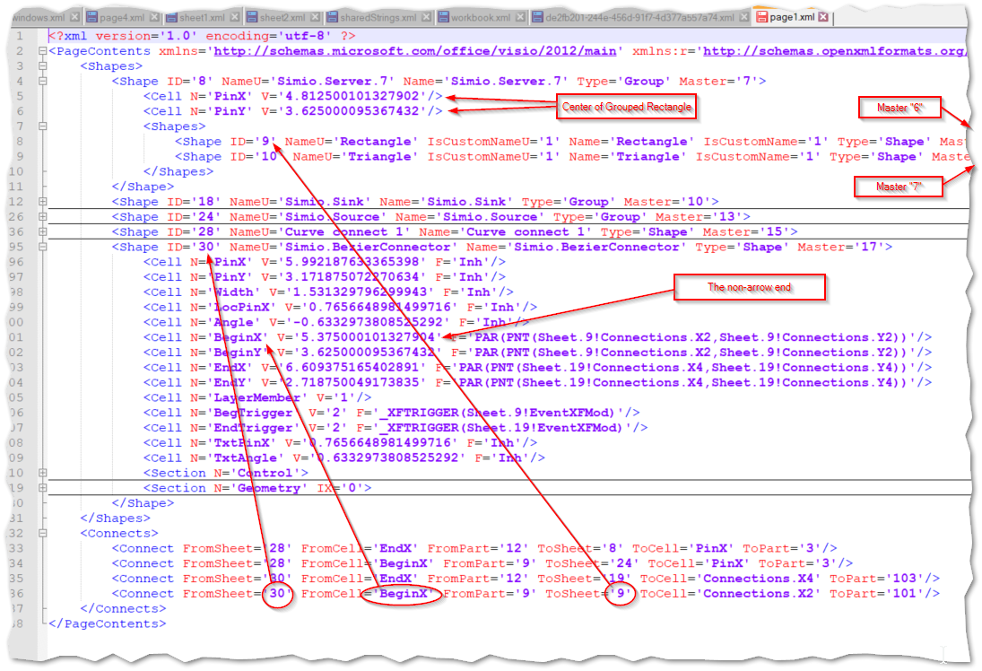

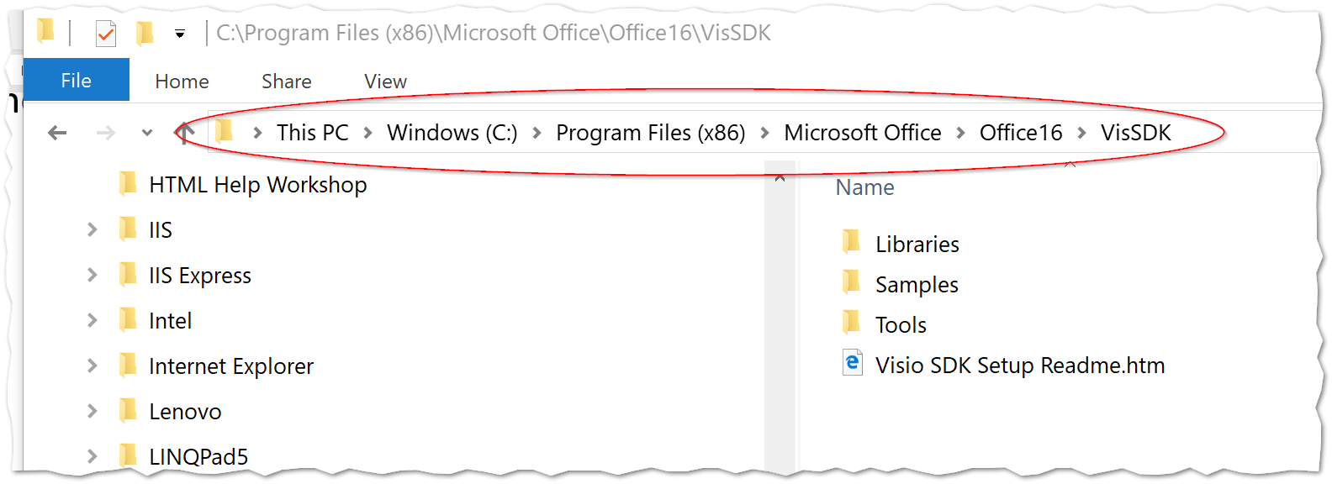

## Example: The “Source” Shape

The Source is one of the simplest Shapes:

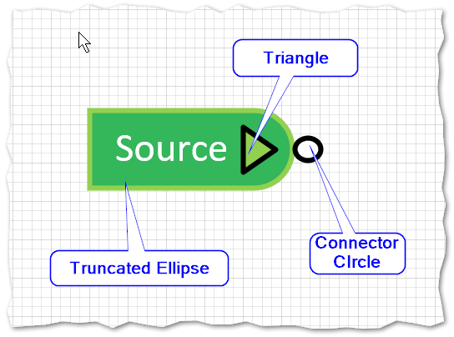

If we look at a “Source” Shape in the Page1.XML file, we can see that it has an ID of “1”, a Name of “Simio.Source.14” and reference to Master14, which is defined in the Masters.xml file:

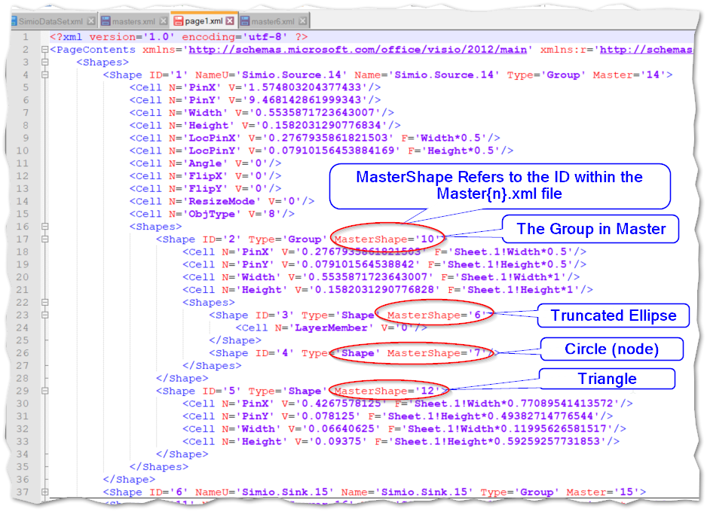

Figure 14 - The 'Source' Shape within the Page1.xml file

This Master with an ID of 14 in Masters.xml then references the file Master6.xml (look at the Rel Element at the bottom) by specifying <Rel r:id=’rId6’ />:

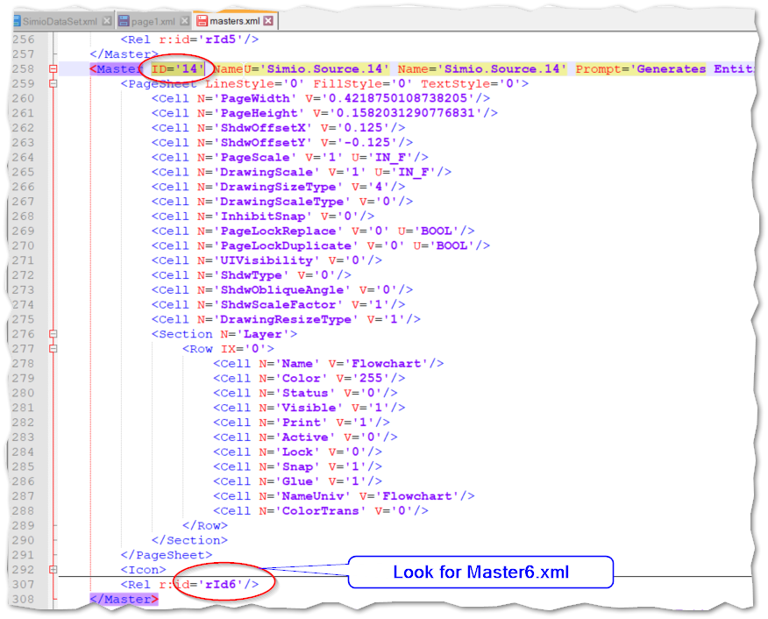

Figure 15 - The 'Source' Master within Masters.xml

And Master6.xml contains all the template characteristics of this Master Shape. Remember that the Shape (with ID of ‘1’) that referenced this (see above) had sub-Shape Elements with MasterShape attributes that referenced these shapes in this Master6.xml file.

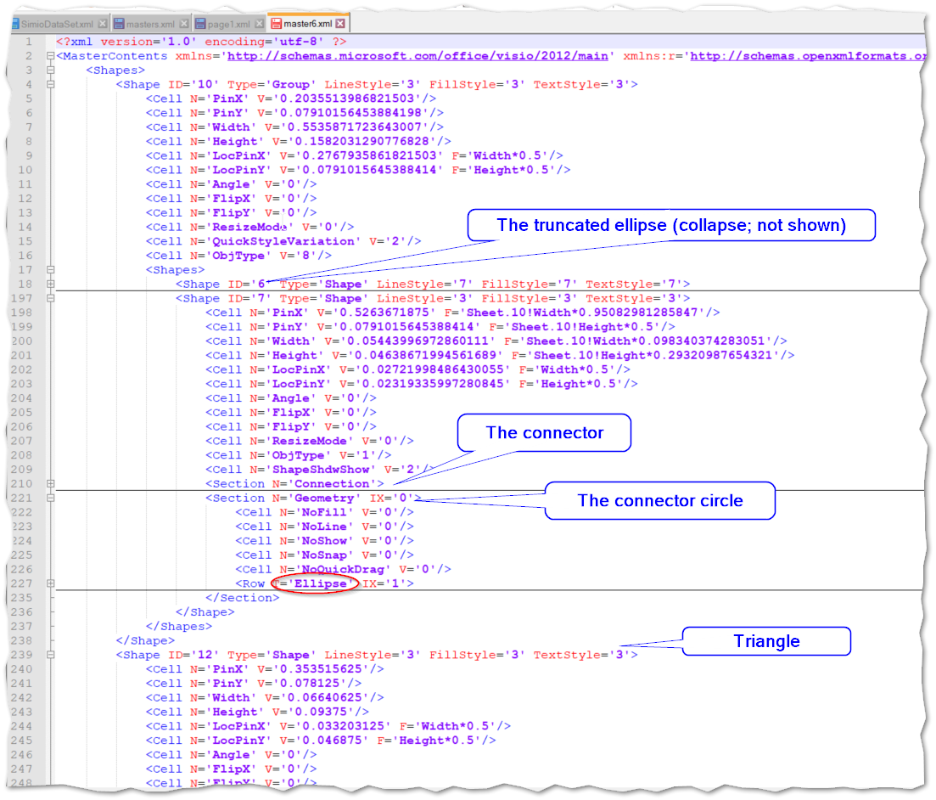

Figure 16 - The 'Source' Master (Master6.xml)

# Appendix – Developer Resources

This appendix lists several resources available to the Developer, including some older interface options.

Videos from <http://www.visguy.com>

These videos provide an overview of Visio concepts. The YouTube locations are below.

* [Visio, a flyby for developers - Module 1 - YouTube](https://www.youtube.com/watch?v=qsazcJ8pYJc)
* [Visio, a flyby for developers - Module 2 - YouTube](https://www.youtube.com/watch?v=gj1Ak7fAHA0)

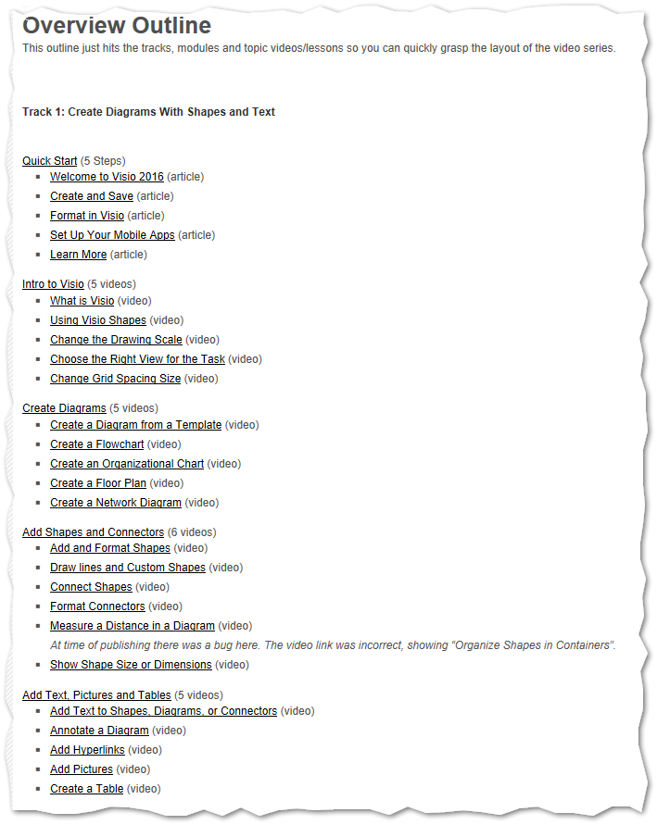

These are online. For example: Custom Stencils: <https://support.office.com/en-us/article/video-create-save-and-share-custom-stencils-b08cd9dd-58ee-48f7-889d-606d488c0e05?ui=en-US&rs=en-US&ad=US>

## The Drawing Control

The drawing control is an older interface that depends upon OCX and Interop.

References:

There are 3 reference to the GAC:

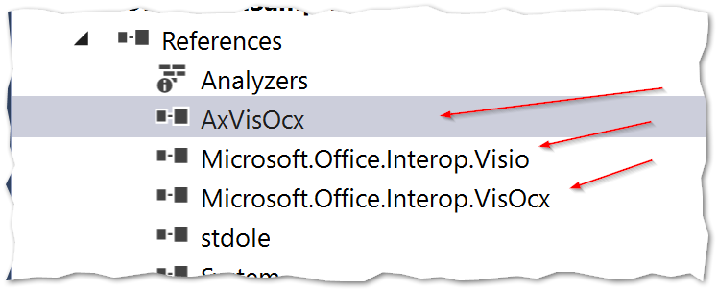

Note that the VisOcx is the needed for the drawing control.

Here is code to find the masters in a visio diagram:

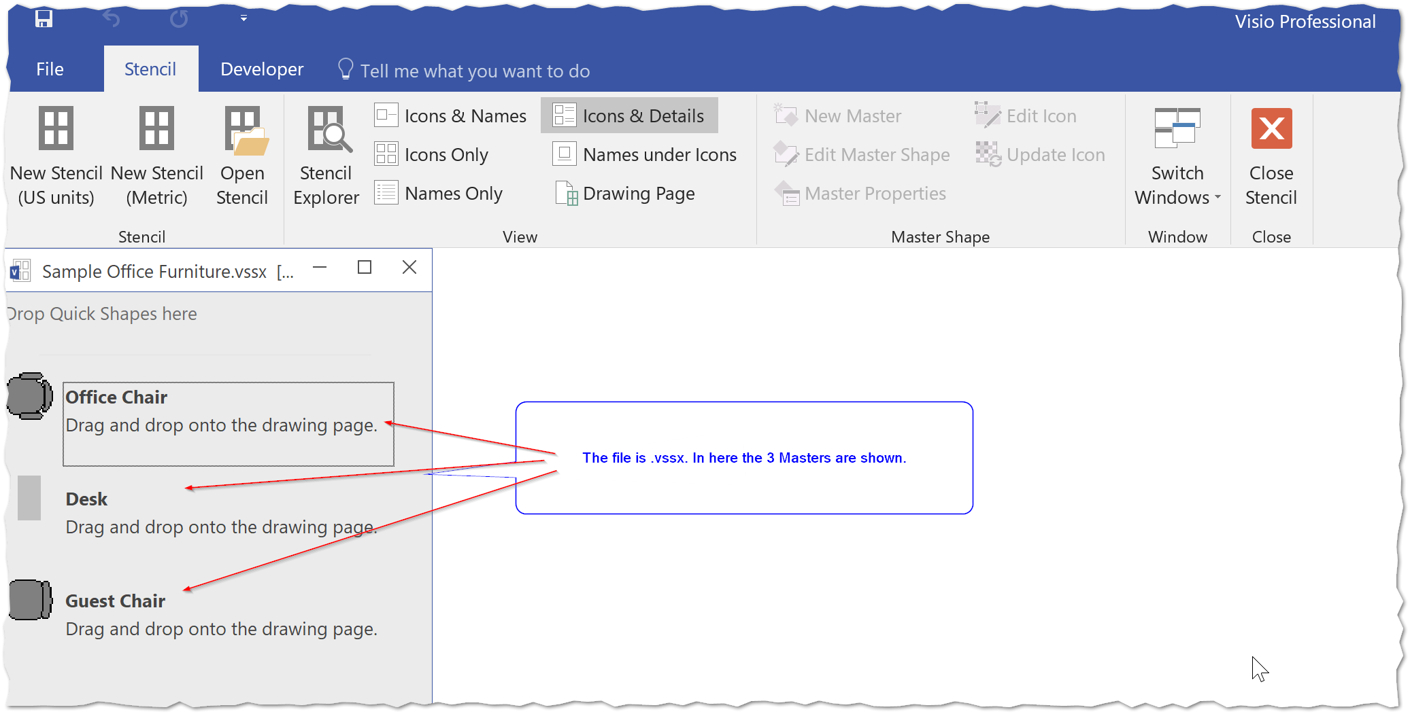

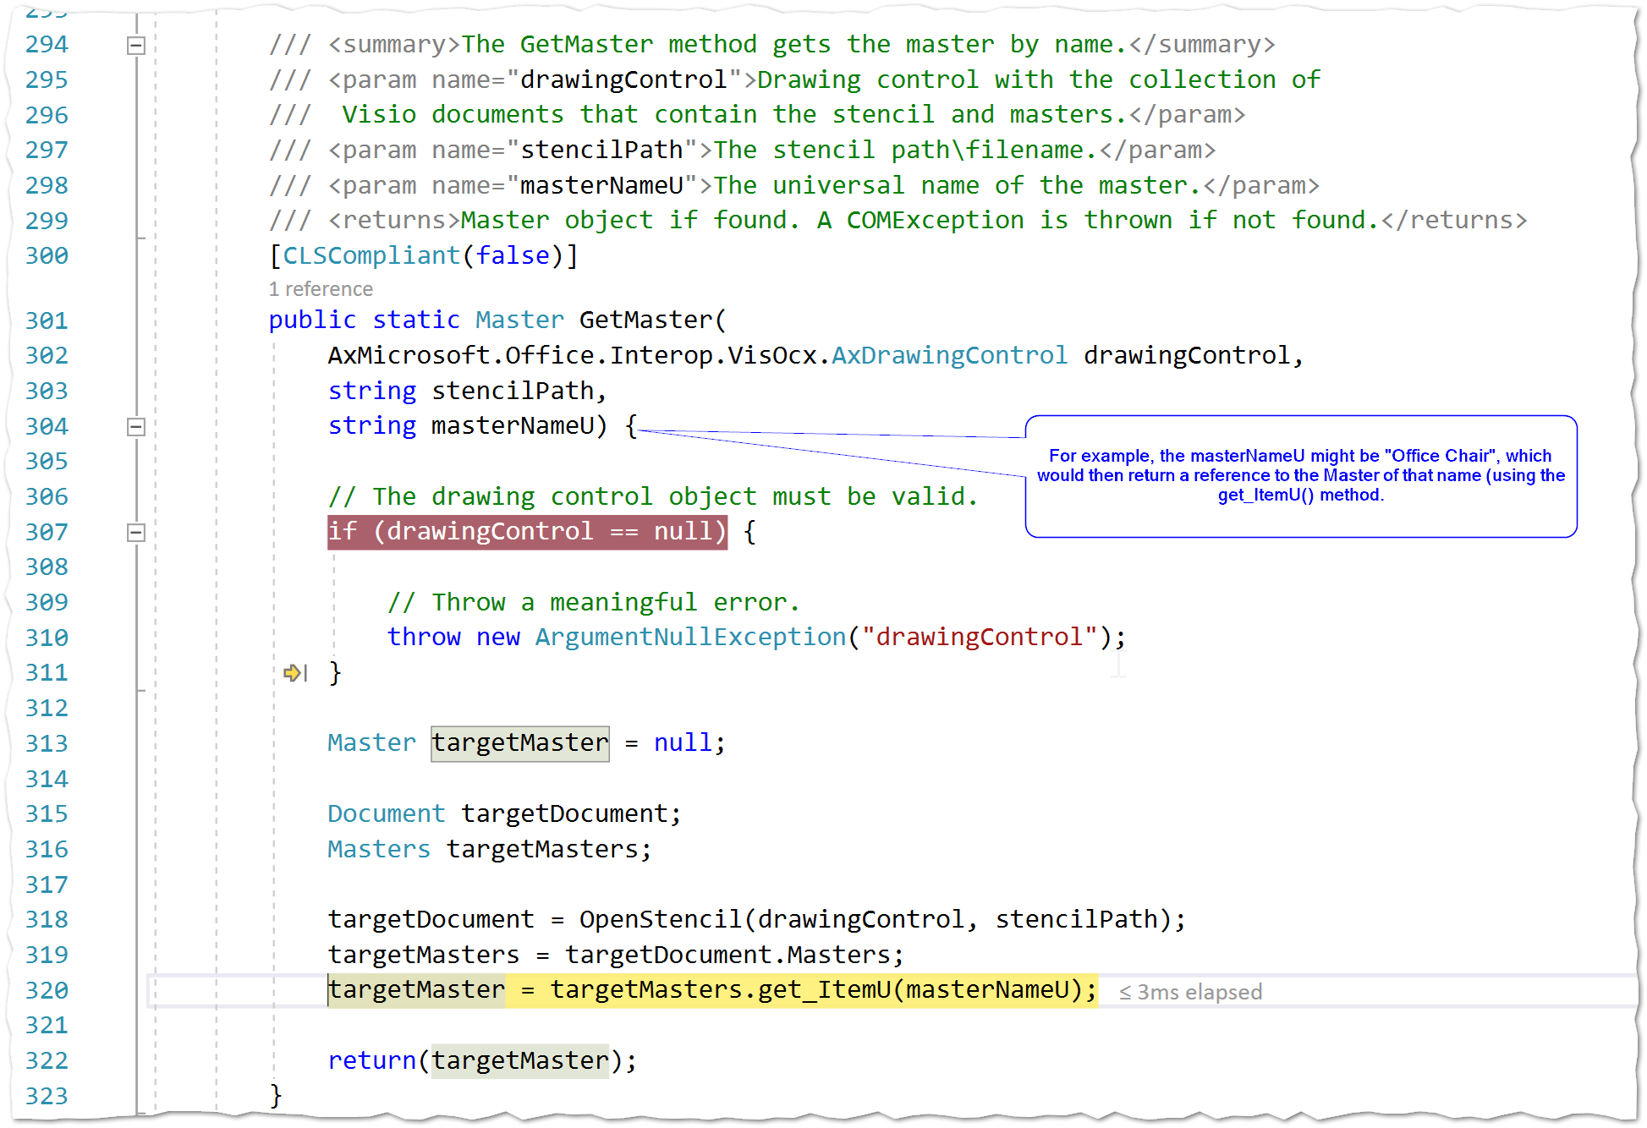

## Visio Documents

<https://msdn.microsoft.com/en-us/library/cc160751.aspx>

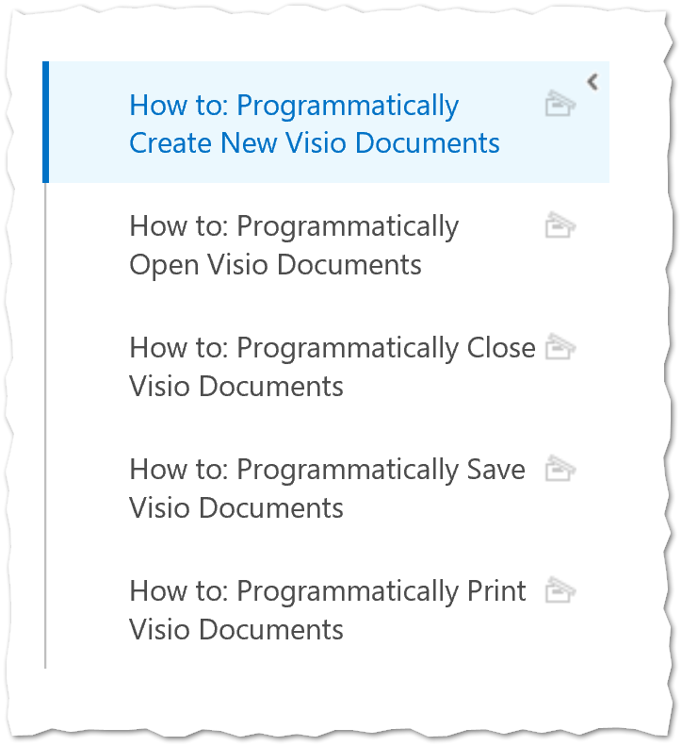

<https://msdn.microsoft.com/en-us/library/cc160747.aspx>

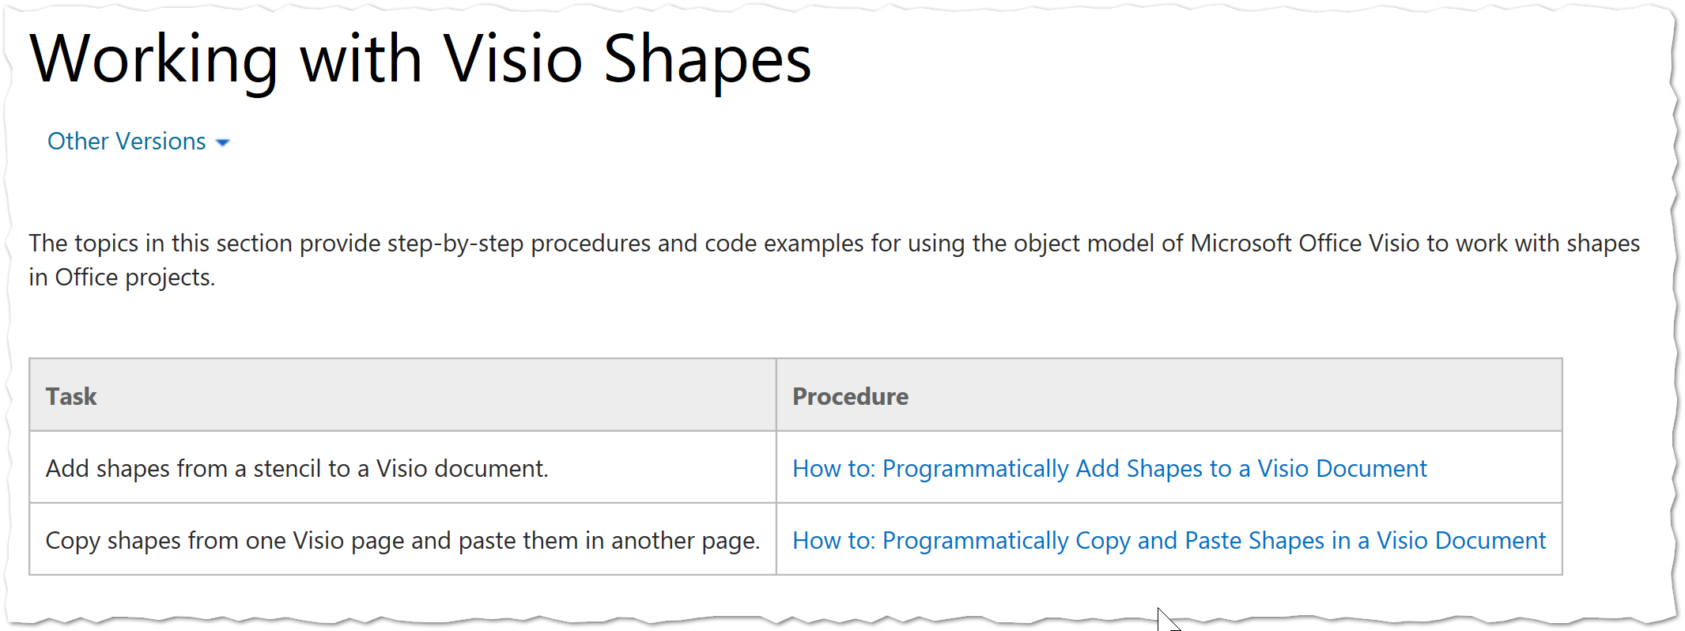

Programmatically add Shapes

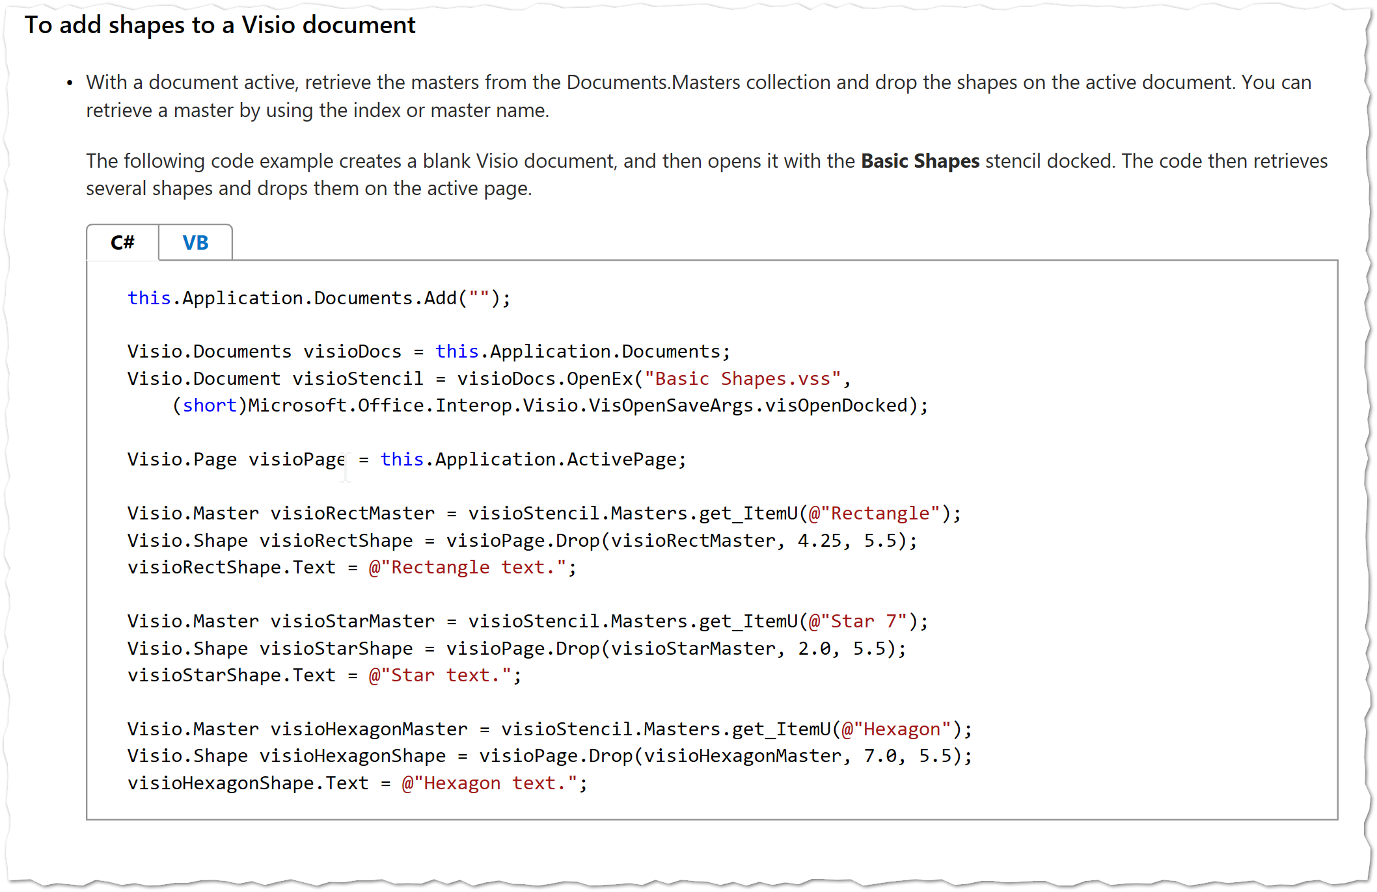

“All of the objects and members in the VBA object model reference correspond to types and members in the Visio primary interop assembly (PIA). For example, the **Document** object in the VBA object model reference corresponds to the **Microsoft.Office.Interop.Visio.Document** type in the Visio PIA. Although the VBA object model reference provides code examples for most properties, methods, and events, you must translate the VBA code in this reference to Visual Basic or Visual C# if you want to use them in a Visio VSTO Add-in project that you create by using Visual Studio,”

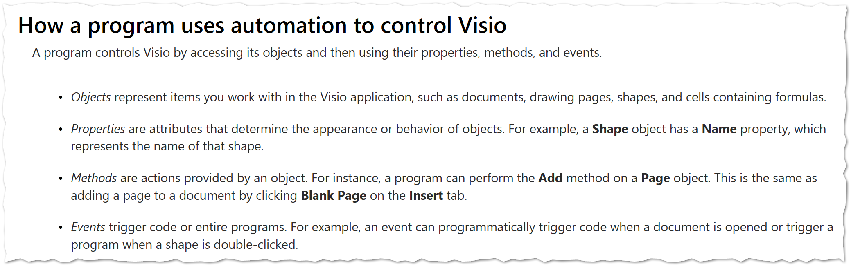

# Appendix – Imported Data Conventions

## Objects

* ObjectClass
* ObjectName
* X,Y,Z (doubles)
* Length, Width, Height (doubles)
* EntityType
* InitialNumberInSystem
* RideOnTransporter
* TransporterName
* PropertyA
* PropertyB
* PropertyC

## Links

* LinkClass (e.g. Path)
* LinkName
* FromNode
* ToNode
* Network
* Width, Height
* Type (Bidirectional)
* PropertyA
* PropertyB
* PropertyC

## Vertices

LinkName

VertexX

VertexY

VertexZ

# Appendix – Excel OPC Format

Excel in OPC Format:

Excel (after 2007, at least) is all about representing a series of Worksheets, which are – in turn – a series of sparse matrices.

Like many Microsoft Office Products, Excel employs the Open Package Convention format for storing information.

For Simio, the Worksheets can be of the following types:

1. Object
2. Links
3. Vertices

Under XL

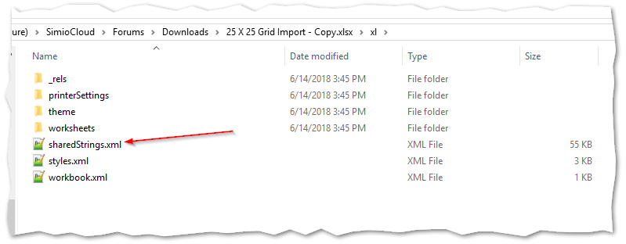

### XML File: sharedString

The odd duck here is the sharedStrings.XML, which contains a list of unique string. A guess as to why this is may be that in Excel many strings are often repeated, so the developers felt that this would increase storage efficiency.

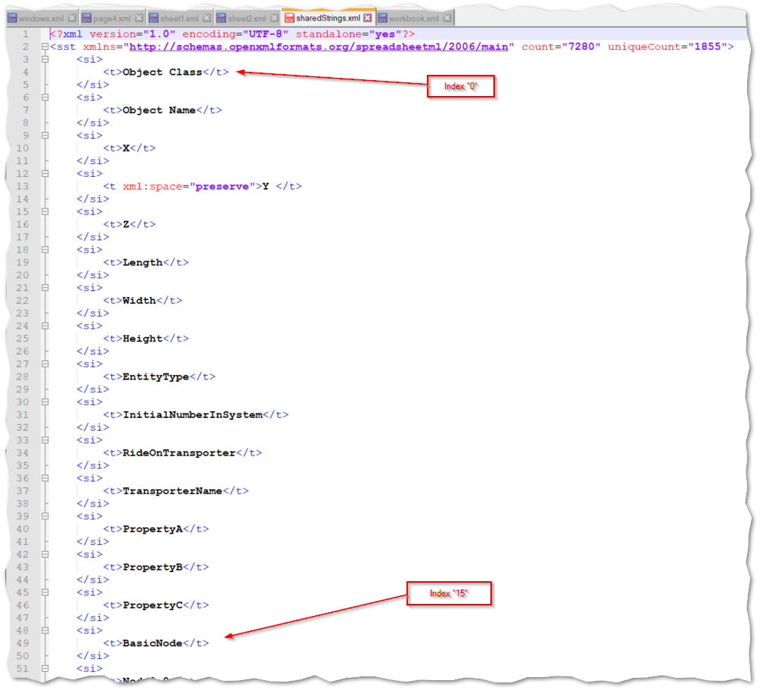

## WorkBook File

Ties the WorkSheets together:

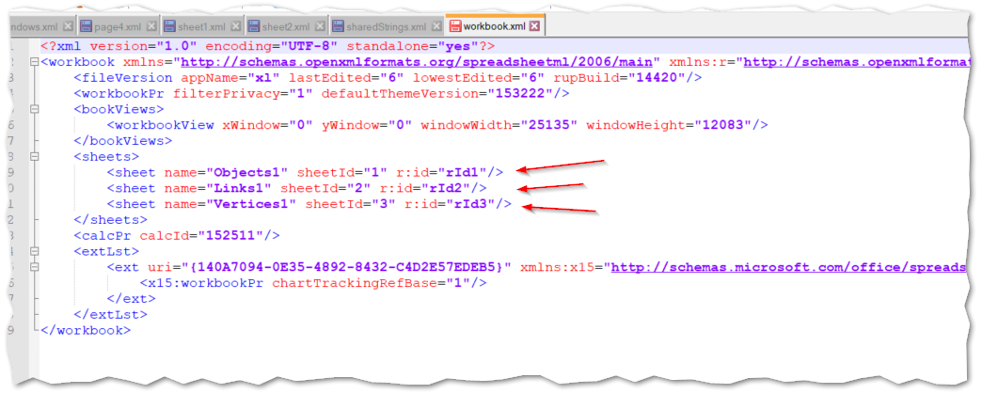

## WorkSheets

Under XL is the WorkSheets folder

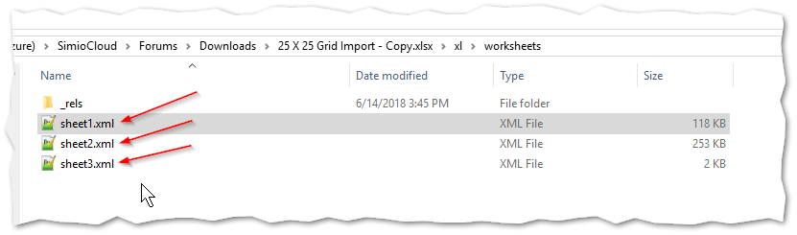

The Excel has three Worksheets: Objects, Links, and Vertices

Each type of worksheet has the Property names in the first row, and then “records” for the remaining.

The first column (field) must always contain a value.

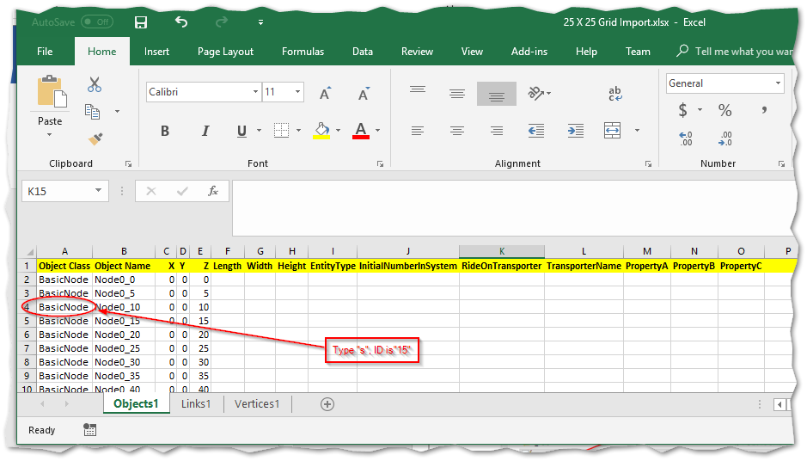

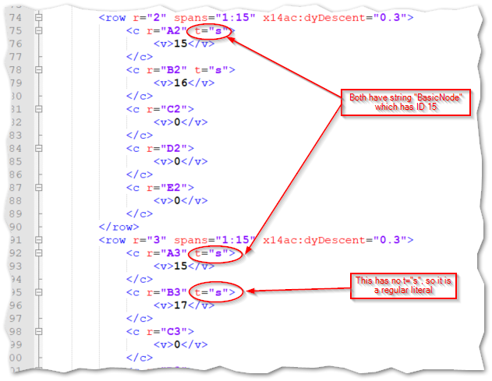

# Appendix – Simio Project Container File (SPFX)

The Simio Project Container File (.SPFX) is stored in its own file, which is like an OPC structure (but as of this writing does *not* exactly conform to the OPC standard).

Objects contain the Simio objects. Within Objects are Simio Intelligent objects. In the example below, there is a Fixed object of Type “Source”, which contains a Node of type “TransferNode”.

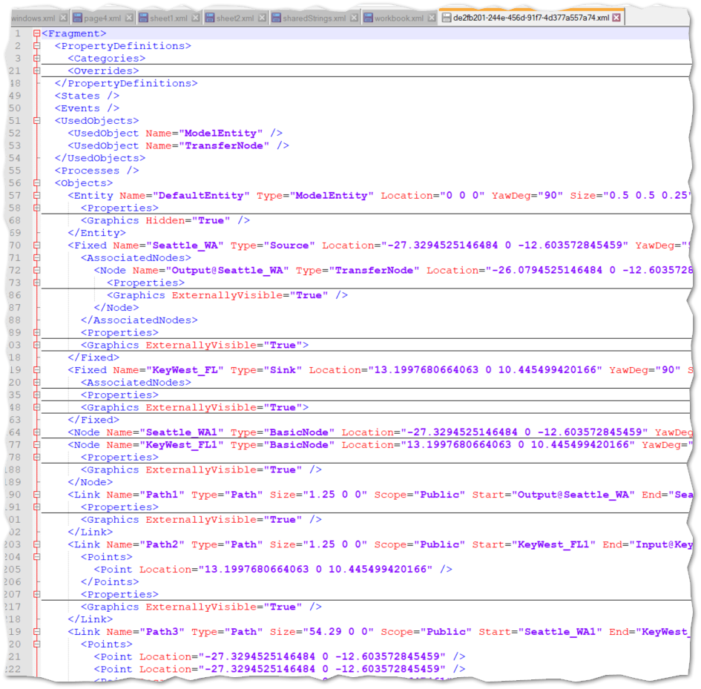

Also seen are Link objects, which have ‘Start’ and ‘End’ attributes that reference Nodes. A Node can be an object, existing directly under Objects and can also be referenced by another object, as seen by the Output@Seattle_WA being nested under the ‘Source’ object Seattle_WA.

A large path is shown below, with its geometry being represented by Points within a Link (and the Link referencing the Nodes to which the Link is connecting).

